UNITED STATES
SECURITIES AND EXCHANGE COMMISSION
Washington, DC 20549

FORM 8-K

CURRENT REPORT

Pursuant to Section 13 or 15(d) of the Securities Exchange Act of 1934
Date of Report (Date of earliest event reported): June 22, 2022

Athira Pharma, Inc.

(Exact name of registrant as specified in its charter)

Delaware | 001-39503 | 45-3368487
(State or other jurisdiction | (Commission | (IRS Employer
of incorporation) | File Number) | Identification No.)
 | 18706 North Creek Parkway, Suite 104
 | Bothell, WA 98011
 | (Address of principal executive offices, including zip code)
 | (425) 620-8501
 | (Registrant’s telephone number, including area code)
 | (Former name or former address, if changed since last report)

Check the appropriate box below if the Form 8-K filing is intended to simultaneously satisfy the filing obligation of the registrant under any of the following provisions (see
General Instruction A.2. below):

- Written communications pursuant to Rule 425 under the Securities Act (17 CFR 230.425)

- Soliciting material pursuant to Rule 14a-12 under the Exchange Act (17 CFR 240.14a-12)

- Pre-commencement communications pursuant to Rule 14d-2(b) under the Exchange Act (17 CFR 240.14d-2(b))

- Pre-commencement communications pursuant to Rule 13e-4(c) under the Exchange Act (17 CFR 240.13e-4(c))

Securities registered pursuant to Section 12(b) of the Act:

Title of each class

Trading Symbol(s)

Name of each exchange on which registered

Common Stock, $0.0001 par value per share

ATHA

The Nasdaq Stock Market LLC
(The Nasdaq Global Select Market)

Indicate by check mark whether the registrant is an emerging growth company as defined in Rule 405 of the Securities Act of 1933 (§230.405 of this chapter) or Rule 12b-2 of the Securities Exchange Act of 1934 (§240.12b-2 of this chapter).

Emerging Growth Company ☒

If an emerging growth company, indicate by check mark if the registrant has elected not to use the extended transition period for complying with any new or revised financial accounting standards provided pursuant to Section 13(a) of the Exchange Act). ☐

Item 8.01 Other Events.

On June 22, 2022, Athira Pharma, Inc. (the “Company”) issued a press release announcing the topline results from the Company’s exploratory ACT-AD Phase 2 study of fosgonimeton in mild-to-moderate Alzheimer’s Disease.

A copy of the Company’s press release is attached hereto as Exhibit 99.1 and is incorporated herein by reference.

Item 7.01 Regulation FD Disclosure.

The Company will host a live webcast to discuss the ACT-AD results in greater detail at 8:30 a.m. ET today, Wednesday, June 22, 2022. To access the live webcast, please visit the "Events and Presentations" page within the Investors section of the Athira website https://investors.athira.com/news-and-events/events-and-presentations. As part of the webcast, the Company will present certain slides relating to the ACT-AD results, which slides are attached as Exhibit 99.2 hereto.

The information in Item 7.01 of this Current Report on Form 8-K, including the slides to be used during the webcast and attached as Exhibit 99.2 hereto, are being furnished and not filed pursuant to Item 7.01 of Form 8-K. Such information shall not be deemed to be “filed” for purposes of Section 18 of the Exchange Act of 1934, as amended (the “Exchange Act”), or otherwise subject to the liabilities of that section, and shall not be deemed to be incorporated by reference into any of the Company’s filings under the Securities Act of 1933, as amended, or the Exchange Act whether made before or after the date hereof and regardless of any general incorporation language in such filings, except to the extent expressly set forth by specific reference in such a filing.

Item 9.01 Financial Statements and Exhibits.

(d) Exhibits.

Exhibit No. |  |  | Description
99.1 |  |  | Athira Pharma, Inc. press release dated June 22, 2022.
99.2 |  |  | Athira Pharma, Inc. presentation slides.
104 |  |  | Cover Page Interactive Data File (formatted as Inline XBRL)

SIGNATURES

Pursuant to the requirements of the Securities Exchange Act of 1934, the registrant has duly caused this report to be signed on its behalf by the undersigned hereunto duly authorized.

 |  | Athira Pharma, Inc.
Date: June 22, 2022 | By: | /s/ Mark Litton
 |  | Mark Litton
 |  | President and Chief Executive Officer

Exhibit 99.1
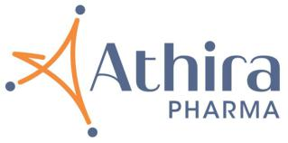

Athira Pharma Announces Topline Results from ACT-AD Phase 2 Proof of Concept Study of Fosgonimeton in Mild-to-Moderate Alzheimer’s Disease

Primary endpoint of change in biomarker ERP P300 latency was not statstcally signifcant for the full study populaton as combinaton of fosgonimeton and standard-of-care (AChEIs) given together showed potental diminished efect of fosgonimeton

A pre-specifed subgroup analysis of patents on fosgonimeton monotherapy suggests improvement in both ERP P300 latency and ADAS-Cog11 at week 26 compared to placebo indicatng pharmacological actvity

Fosgonimeton had a favorable safety profle over 26 weeks and ACT-AD provides important learnings for ongoing LIFT-AD study

Athira to host live webcast today at 8:30 am Eastern tme

BOTHELL, Wash., June 22, 2022 -- Athira Pharma, Inc. (NASDAQ: ATHA), a late clinical-stage biopharmaceutcal company focused on developing small molecules to restore neuronal health and slow neurodegeneraton, today announced topline results from its exploratory ACT-AD Phase 2 study of fosgonimeton (ATH-1017) in patents with mild-to-moderate Alzheimer’s disease (AD). Fosgonimeton is a small molecule designed to enhance the actvity of Hepatocyte Growth Factor (HGF) and its receptor, MET, which are expressed in the central nervous system to promote brain health and functon.

“Following compelling ERP P300 latency biomarker data from a small Phase 1b trial over eight days in Alzheimer’s patents on fosgonimeton monotherapy, this Phase 2 trial provides valuable insights into the nature of this novel interventon over 26 weeks. ACT-AD was designed as a learning study to further investgate the ERP P300 biomarker signal over 6 months, assess safety in a patent populaton more representatve of the real world, by allowing the use of add-on standard-of-care acetylcholinesterase inhibitors (AChEIs, e.g., donepezil), and explore fosgonimeton’s efect on psychometric outcomes, including ADAS-Cog11, to inform the ongoing Phase 3 LIFT-AD study. To that end, this study achieved its goal,” said Hans Moebius, M.D., Ph.D., Chief Medical Ofcer of Athira.

“The study was intended to show diferences on the biomarker ERP P300 latency. This primary endpoint was not met by protocoled analysis, however a pre-specifed subgroup analysis indicated a potental diminished efect of fosgonimeton when given in combinaton with AChEIs. A subsequent post hoc analysis of the data from patents on fosgonimeton monotherapy showed a meaningful improvement in both ERP P300 latency (-28 milliseconds) and cognitve performance (ADAS-Cog11: -3.3 points) compared to placebo at 26 weeks.

“These data points are very encouraging as they indicate the expected pharmacological actvity of fosgonimeton by parallel improvement on ERP P300 latency and ADAS-Cog11 and show a favorable safety profle over six months. This is the frst tme monotherapy fosgonimeton has shown an efect on ADAS-Cog11, suggestng a potental cognitve beneft. We will use these insights for a ratonal optmizaton of the ongoing LIFT-AD trial. We plan to seek advice from our scientfc advisors, investgators, and ultmately regulators on how to expeditously analyze and potentally adapt the LIFT-AD study,” added Dr. Moebius.

“The data from the fosgonimeton monotherapy analysis are encouraging and show biologic actvity that may support the potental role of the HGF/MET pathway in neurodegeneratve diseases,” said Marwan Sabbagh, M.D., FAAN, professor of neurology at Barrow Neurological Insttute, Phoenix, AZ. “ACT-AD adds to the body of literature suggestng ERP P300 latency as an important biomarker for cognitve status.”

ACT-AD Study Design and Results

ACT-AD was an exploratory, randomized, double-blind, placebo-controlled, parallel-group 26-week trial evaluatng fosgonimeton compared to placebo in patents with mild-to-moderate Alzheimer’s disease. The study enrolled 77 patents in the United States and Australia (age 55 to 85 years, Mini-Mental State Exam (MMSE) score of 14-24 and Clinical Dementa Ratng (CDR) scale global score of 1 or 2). Patents were allowed to contnue standard-of-care therapy (AChEIs), with 60 percent remaining on stable doses of AChEIs and 40 percent not receiving AChEIs during the study. Patents were randomized 1:1:1 to receive placebo or fosgonimeton at either 40 mg/d or 70 mg/d. The primary endpoint for ACT-AD was Event-Related-Potental (ERP) P300 Latency, a functonal measure of working memory processing speed. Secondary endpoints included ADAS-Cog11, a measure of cogniton; ADCS-CGIC, a measure of global clinical change; and ADCS-ADL23, a measure of functonal change. Safety data were evaluated throughout. The study was only powered to show statstcal signifcance for change in ERP P300 latency.

The ACT-AD study did not meet the primary endpoint of a statstcally signifcant change in ERP P300 Latency for the modifed intent to treat (mITT) populaton by a mixed model repeated measures (MMRM) analysis (-6.02 milliseconds) when compared with placebo at 26 weeks in a pooled analysis of the

- mg and 70 mg dose groups. Secondary endpoints, including ADAS-Cog11, ADCS-CGIC, and ADCS-ADL23, were not signifcant in treated subjects compared with placebo at 26 weeks. A pre-specifed subgroup analysis identfed a potental diminished efect of the combinaton of standard-of-care (AChEIs) and fosgonimeton. Other subgroup analyses, to-date, including dose, disease severity and APOE genotype, did not show diferences between groups.

A post hoc analysis, based on the mITT populaton on fosgonimeton monotherapy, showed a potentally benefcial change in ERP P300 compared to placebo at 26 weeks (-28 milliseconds) as well as cognitve improvement as measured by ADAS-Cog11 (-3.3 points) compared with placebo at 26 weeks.

ACT-AD ERP P300 Latency post hoc analysis: mITT populaton, Wilcoxon analysis
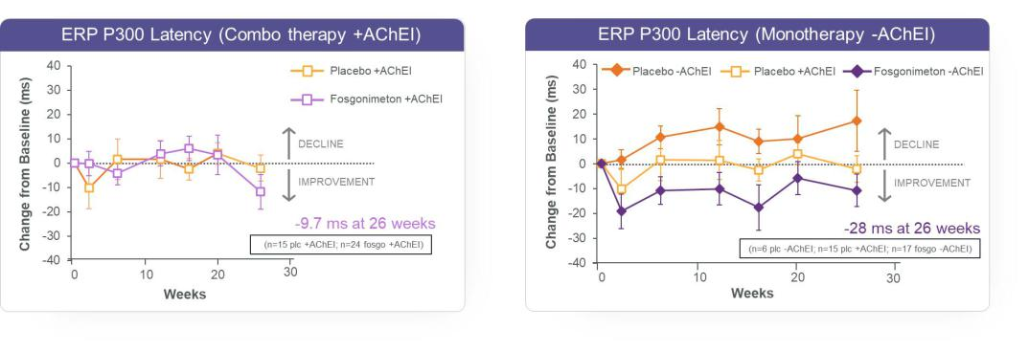

ACT-AD ADAS-Cog11 post hoc analysis: mITT populaton, Wilcoxon analysis
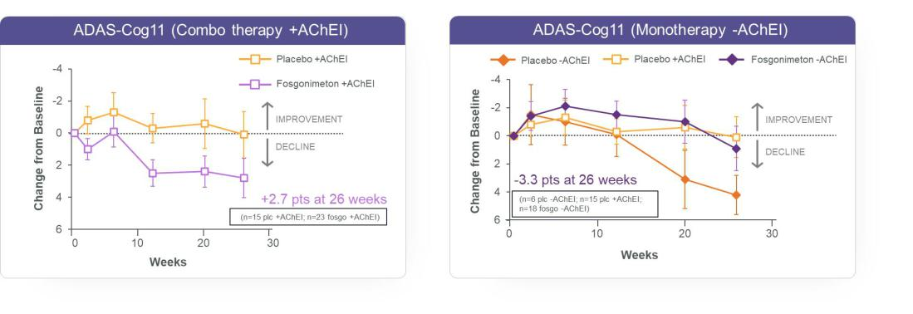

Fosgonimeton was generally well tolerated, with a favorable safety profle. There were no treatment related Serious Adverse Events or deaths observed in the study. Partcipants treated with fosgonimeton at 40mg or 70mg for 26 weeks showed a higher incidence of treatment emergent adverse events compared to placebo. The most frequent adverse event was injecton site reacton, sometmes associated with transient and asymptomatc increases in absolute Eosinophil count. The study had a 14 percent early terminaton rate.

Full analysis results are scheduled to be presented at the Alzheimer’s Associaton Internatonal Conference (AAIC) taking place July 31 – August 4, 2022.

“As planned, the ACT-AD study results have provided us with important insights that we will use to inform our ongoing LIFT-AD study, which is enrolling mild-to-moderate AD patents. We are encouraged by these data as they show more than just biologic actvity; although a small sample size, they suggest a potentally benefcial treatment efect as a monotherapy that in the ACT-AD study was similar to standard-of-care with a favorable safety profle,” said Mark Liton, Ph.D., President and Chief Executve Ofcer of Athira.

“We are in the fortuitous situaton that we have a much larger trial ongoing with more than 200 patents completng at least 20 weeks of treatment providing us with an opportunity to obtain more insights in an expedited manner. Our strong cash positon allows us to contnue to progress fosgonimeton development.

“In additon to the biomarker results from both the Phase 1b and this study, these data are the frst to show fosgonimeton’s potental efect on a key measure of cognitve improvement in Alzheimer’s disease patents by positve modulaton of the HGF/MET receptor by fosgonimeton as a monotherapy. We contnue to enroll in the open-label extension study that was recently extended to 18 months. We are grateful to the clinicians and patents, along with their families and caregivers, who partcipated in this trial and contnue to support the scientfc community in our endeavors to bring new optons to patents in need,” concluded Dr. Liton.

Additonal informaton on the ACT-AD study can be found at: NCT04491006. The ACT-AD trial is supported by a grant from the Natonal Insttute on Aging of the Natonal Insttutes of Health under Award Number R01AG06268. The informaton presented in this press release is solely the responsibility of Athira and does not necessarily represent the ofcial views of the Natonal Insttutes of Health.

About the Phase 3 LIFT-AD Clinical Study

LIFT-AD is a randomized, double-blind, placebo-controlled, parallel-group Phase 3 study of fosgonimeton for patents with mild-to-moderate Alzheimer’s disease. The study will enroll approximately 420 patents in the United States, with enrollment ongoing. Patents are randomized across two dose groups and one placebo group on a 1:1:1 basis to receive a subcutaneous injecton of fosgonimeton or placebo once daily over a treatment course of 26 weeks. The primary endpoint for LIFT-AD will be measured by the Global Statstcal Test, which is a mathematcal algorithm that combines the scores from cogniton (Alzheimer's Disease Assessment Scale-Cognitve Subscale [ADAS-Cog11]), and either global impression of change (Alzheimer's Disease Cooperatve Study-Clinical Global Impression of Change [ADCS-CGIC]), or functon (Alzheimer’s Disease Cooperatve Study-Actvites of Daily Living [ADCS-ADL23]). Additonal informaton on the study can be found at: NCT04488419.

About Fosgonimeton (ATH-1017)

Fosgonimeton (ATH-1017) is a small molecule designed to enhance the actvity of hepatocyte growth factor (HGF) and its receptor, MET, to impact neurodegeneraton and regenerate brain tssue. The functon of the HGF/MET receptor system may be impaired in the brain under conditons of neurodegeneraton. In additon to Alzheimer’s disease, fosgonimeton has the potental to address the broader dementa populaton, including Parkinson’s disease dementa and Dementa with Lewy bodies, as the mode of acton focuses on network recovery and synaptc signal transmission in the brain.

About Alzheimer’s Disease

Alzheimer’s disease (AD) is a progressive neurodegeneratve disorder that currently afects an estmated 6.5 million Americans aged 65 and older, according to the Alzheimer’s Associaton. AD has multfactorial and complex pathologies that involve the nervous system, vasculature, immune system and neurotransmiters. One early event of AD progression is the loss of 25-36% of synapses, which impacts several brain regions, including the hippocampus and frontal cortex, regions important for learning and memory. In AD, the expression of neuronal MET is reduced by 75% in the hippocampus and 25% in the frontal cortex, suggestng that dysregulaton of HGF/MET could be implicated in AD and other brain pathologies.

Live Webcast

Athira will host a live webcast to discuss the ACT-AD results in greater detail at 8:30 a.m. ET today, Wednesday, June 22, 2022. To access the live webcast, please visit the "Events and Presentatons" page within the Investors secton of the Athira website htps://investors.athira.com/news-and-events/events-and-presentatons. An archived replay will also be available on the website for at least 90 days following the event.

About Athira Pharma, Inc.

Athira Pharma, Inc., headquartered in the Seatle area, is a late clinical-stage biopharmaceutcal company focused on developing small molecules to restore neuronal health and slow neurodegeneraton. Athira aims to provide rapid cognitve improvement and alter the course of neurological diseases with its novel mechanism of acton. Athira is currently advancing its lead candidate, fosgonimeton, a novel small molecule for Alzheimer’s, Parkinson’s disease dementa and Dementa with Lewy bodies. For more informaton, visit www.athira.com. You can also follow Athira on Facebook, LinkedIn and @athirapharma on Twiter and Instagram.

Forward-Looking Statements

This release contains “forward-looking statements” within the meaning of Secton 27A of the Securites Act of 1933, Secton 21E of the Securites Exchange Act of 1934 and the Private Securites Litgaton Reform Act of 1995. These forward-looking statements are not based on historical fact and include statements regarding fosgonimeton as a potental treatment for Alzheimer’s disease, Parkinson’s disease dementa and Dementa with Lewy bodies, and other dementas; Athira’s platorm technology and potental therapies; future development plans; clinical and regulatory objectves and the tming thereof; expectatons regarding the potental efcacy and commercial potental of Athira’s product candidates; the antcipated reportng of data; the potental learnings from the ACT-AD trial and their ability to inform and improve future clinical development plans; and Athira’s ability to advance its product candidates into later stages of development. Forward-looking statements generally include statements that are predictve in nature and depend upon or refer to future events or conditons, and include words such as “may,” “will,” “should,” “would,” “expect,” “plan,” “believe,” “intend,” “pursue,” “contnue,” and other similar expressions, among others. Any forward-looking statements are based on management’s current expectatons of future events and are subject to a number of risks and uncertaintes that could cause actual results to difer materially and adversely from those set forth in or implied by such forward-looking statements. These risks and uncertaintes include, but are not limited to, the preliminary data for Athira’s fosgonimeton product candidate from the Phase 1a/b and Phase 2

ACT-AD trials will not contnue or persist in current or planned clinical trials; cessaton or delay of any of the ongoing clinical trials and/or Athira’s development of fosgonimeton and other product candidates may occur; the impact of the COVID-19 pandemic on Athira’s business, research and clinical development plans and tmelines, and the regulatory process for Athira product candidates; Athira may not be able to recruit sufficient patients for its clinical

trials; future potential regulatory milestones of fosgonimeton and other product candidates, including those related to current and planned clinical studies may be insufficient to support regulatory submissions or approval; the outcome of legal proceedings which have been or may in the future be insttuted against us and

certain of our directors and ofcers; clinical trials may not demonstrate safety and efcacy of any of Athira’s product candidates; possible negative interactions of Athira's product candidates with other treatments; Athira’s assumptons regarding the sufciency of its cash, cash equivalents and investments to fund its planned operatons may be incorrect; while P300 latency is a functonal measure that is highly correlated with cogniton, Athira may not successfully establish a connecton between these P300 latency results and improved cogniton; adverse conditions in the general domestic and global economic markets;

the impact of competition; regulatory agencies may be delayed in reviewing, commenting on or approving any of Athira’s clinical development plans as a result of the COVID-19 pandemic, which could further delay development timelines; the impact of expanded product development and clinical activities on operating expenses; the impact of new or changing laws and regulations; as well as the other risks detailed in Athira’s flings with the Securites and Exchange

Commission. These forward-looking statements speak only as of the date hereof and Athira undertakes no obligaton to update forward-looking statements. Athira may not actually achieve the plans, intentons, or expectatons disclosed in its forward-looking statements, and you should not place undue reliance on the forward-looking statements.

Investor & Media Contact:

Julie Rathbun

Julie.rathbun@athira.com

206-769-9219





