UNITED STATES

SECURITIES AND EXCHANGE COMMISSION
Washington, DC 20549

SCHEDULE 14A

(Rule 14A-101)
PROXY STATEMENT PURSUANT TO SECTION 14(a)

OF THE SECURITIES EXCHANGE ACT OF 1934

Filed by the Registrant ☒

Filed by a Party other than the Registrant ☐

Check the appropriate box:

- Preliminary Proxy Statement

- Confidential, for Use of the Commission Only (as permitted by Rule 14a-6(e)(2))

- Definitive Proxy Statement

- Definitive Additional Materials

- Soliciting Material under § 240.14a-12

Athira Pharma, Inc.

(Name of Registrant as Specified in its Charter)

(Name of Person(s) Filing Proxy Statement, if other than the Registrant)

Payment of Filing Fee (Check all boxes that apply):

- No fee required

- Fee paid previously with preliminary materials

- Fee computed on table in exhibit required by Item 25(b) per Exchange Act Rules 14a-6(i)(1) and 0-11


Athira Mails Letter to Shareholders Highlighting the Strength of its Board and Record of Deliberate Board Refreshment

Urges shareholders to vote “FOR” Athira’s highly qualified, independent director nominees – Joseph Edelman, John M. Fluke, Jr. and Grant Pickering – on the WHITE proxy card

BOTHELL, WA, April 20, 2022 — Athira Pharma, Inc. (NASDAQ: ATHA), a late clinical-stage biopharmaceutical company focused on developing small molecules to restore neuronal health and slow neurodegeneration, today mailed a letter to shareholders highlighting the depth and breadth of experience and expertise on the company’s board.

Athira has a thorough, deliberate process to review board composition and over the past year, the company has added three independent directors with new, valuable skillsets to its board. Seven of the company’s eight directors have joined the board in the last three years. Athira’s directors have backgrounds in clinical development, the regulatory approval process, drug commercialization, finance and financial planning, capital allocation, business development, legal and risk management, and investment management. The directors up for election at this year’s Annual Meeting – Joseph Edelman, John M. Fluke, Jr. and Grant Pickering – collectively possess more than 90 years of deep experience that the board unanimously believes will best position the company during this important chapter.

Athira’s board and leadership team are focused on what matters: advancing Athira’s clinical trials so the company can bring fosgonimeton and the other molecules in Athira’s pipeline to patients and create lasting shareholder value. Supporting Richard A. Kayne in his proxy contest risks substantial disruption to Athira at a critical time for the company. The board unanimously recommends that shareholders vote on the WHITE proxy card today “FOR” Athira’s directors Messrs. Edelman, Fluke and Pickering.

The full text of the letter follows:

April 20, 2022

Dear Fellow Shareholder,

We are seeking your support at Athira’s upcoming annual meeting for our three highly qualified, independent director nominees – Joseph Edelman, John M. Fluke, Jr. and Grant Pickering.

Your board of directors should comprise directors with the expertise needed to advance our strategy. Messrs. Edelman, Fluke and Pickering – together with the rest of our board – possess those skills. For that reason, Athira’s board unanimously recommends a vote for Messrs. Edelman, Fluke and Pickering on the enclosed WHITE proxy card.

We have a thorough, deliberate process to review board composition. Seven of the company’s eight directors have joined the board in the last three years. Over the past year, we have systematically and thoughtfully added specialized experience and expertise to your board. We added an independent director (Barbara Kosacz) who brings substantial legal and operational experience in the biopharma industry. We also appointed two independent directors – Michael Panzara, M.D., MPH and Mr. Pickering – who possess deep clinical development and drug commercialization expertise.

Adding directors with these skillsets has been our focus since Athira’s IPO and especially since the passing of former board chair Tadataka Yamada, M.D. in August 2021. Our focus on adding clinical development and drug commercialization expertise was underway well before Richard A. Kayne commenced his proxy context.

Each of our directors is important to the ongoing success of Athira:
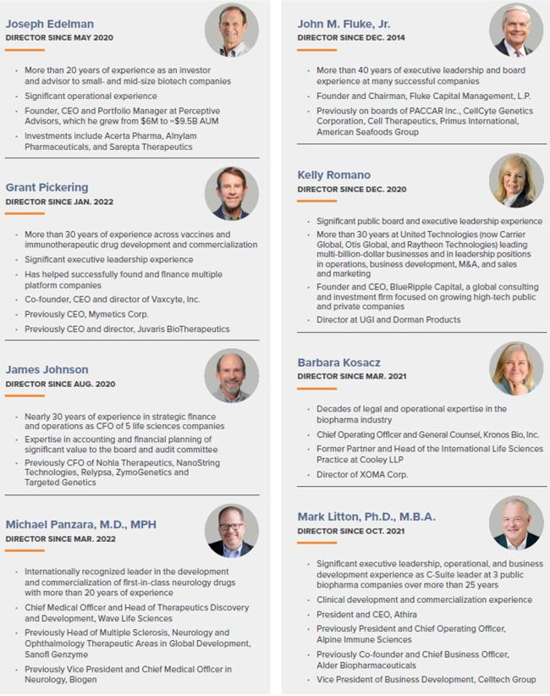

Athira’s directors have the right skills for Athira: clinical development, the regulatory approval process, drug commercialization, finance and financial planning, capital allocation, business development, legal and risk management, and investment management. Messrs. Edelman,

Fluke and Pickering collectively possess more than 90 years of deep experience and expertise that the board unanimously believes will best position the company during this important chapter.
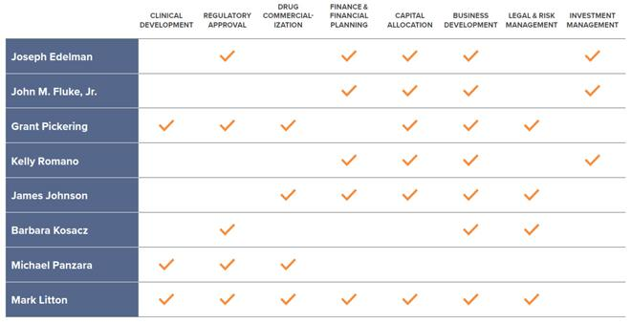

Your board and leadership team are focused on what matters: advancing Athira’s clinical trials so that we can bring fosgonimeton and the other molecules in our pipeline to patients and create lasting shareholder value. We have achieved a number of key milestones over the last several months and are well capitalized and advantageously positioned to execute key objectives with cash on hand to fund the organization through multiple upcoming clinical milestones. With topline results from the Phase 2 ACT-AD study expected by the end of the second quarter of 2022, we are confident that we have the right set of directors to build on our momentum.

PROTECT THE VALUE OF YOUR INVESTMENT – VOTE “FOR” ATHIRA’S THREE NOMINEES ON THE WHITE PROXY CARD TODAY

Don’t let an activist shareholder disrupt Athira’s progress. Richard Kayne is pursuing a misguided and unnecessary proxy contest that is focused on forcing his way onto Athira’s board. He has nominated himself and George Bickerstaff to the board – but their skills are already well represented by our existing directors. Supporting Mr. Kayne in his proxy contest risks substantial disruption to Athira at a critical time for the company.

Athira’s board and leadership team are focused on doing what is right for Athira, our shareholders and our patients and their caregivers. We have the right board and the right leadership team to oversee Athira during this pivotal chapter.

Your vote is important. Whether or not you attend the Annual Meeting, it is important that your shares be represented and voted. Athira’s board unanimously recommends you use the enclosed WHITE proxy card to vote today “FOR” Athira’s three director nominees: Joseph Edelman, John M. Fluke, Jr. and Grant Pickering. Please do not vote using any blue proxy cards you may receive from Mr. Kayne — even as a “protest vote.”

Any vote on Mr. Kayne’s blue proxy card will revoke your prior vote on a WHITE proxy card. Only your latest-dated proxy counts.

Thank you for your continued support,

Your Athira board of directors

VOTE THE WHITE PROXY CARD TODAY


YOUR VOTE IS IMPORTANT!

Follow the instructions on the enclosed WHITE proxy card to vote by telephone, by internet or by signing, dating and returning the WHITE proxy card in the postage-paid envelope provided. If you received this letter by email, you may also vote by pressing the WHITE “VOTE NOW” button in the accompanying email.

Please simply disregard any blue proxy cards that you may receive from Richard Kayne.

If you have questions about how to vote your shares, please call the firm assisting us with the

solicitation of proxies, Innisfree M&A Incorporated, at:

1 (877) 456-3510 (toll-free from the U.S. and Canada)

or

+1 (412) 232-3651 (from other locations)

Advisors

Goldman Sachs & Co. LLC is serving as financial advisor to Athira. Wilson Sonsini Goodrich & Rosati, P.C. is serving as legal advisor to Athira.

About Athira Pharma, Inc.

Athira Pharma Inc., headquartered in the Seattle area, is a late clinical-stage biopharmaceutical company focused on developing small molecules to restore neuronal health and slow neurodegeneration. Athira aims to provide rapid cognitive improvement and alter the course of neurological diseases with its novel mechanism of action. Athira is currently advancing its pipeline therapeutic candidates, targeting the HGF/MET neurotrophic system, for Alzheimer’s and Parkinson’s disease dementia, Dementia with Lewy bodies and neuropsychiatric indications. For more information, visit www.athira.com. You can also follow Athira on Facebook, LinkedIn and @athirapharma on Twitter and Instagram.

Forward-Looking Statements

This communication contains “forward-looking statements” within the meaning of Section 27A of the Securities Act of 1933, Section 21E of the Securities Exchange Act of 1934 and the Private Securities Litigation Reform Act of 1995. These forward-looking statements are not based on historical fact and

include statements regarding fosgonimeton as a potential treatment for Alzheimer’s disease, Parkinson’s disease dementia, Dementia with Lewy bodies, and other dementias; Athira’s platform technology and potential therapies; future development plans; clinical and regulatory objectives and the timing thereof, including the timing of the ACT-AD and LIFT-AD clinical trials and the timing of the Phase 2 clinical trial of fosgonimeton for treatment of Parkinson’s disease dementia; interactions with regulators and the timing thereof, including anticipated timing of IND or equivalent submissions; expectations regarding the potential efficacy and commercial potential of Athira’s product candidates; the anticipated reporting of data; and Athira’s ability to advance its product candidates into later stages of development. Forward-looking statements generally include statements that are predictive in nature and depend upon or refer to future events or conditions, and include words such as “may,” “will,” “should,” “on track,” “would,” “expect,” “plan,” “believe,” “intend,” “pursue,” “continue,” and other similar expressions, among others. Any forward-looking statements are based on management’s current expectations of future events and are subject to a number of risks and uncertainties that could cause actual results to differ materially and adversely from those set forth in or implied by such forward-looking statements. These risks and uncertainties include, but are not limited to, the proxy contest at Athira’s annual meeting; the preliminary data for Athira’s fosgonimeton product candidate from the Phase 1a/b trials will not continue or persist in current or planned clinical trials; cessation or delay of any of the ongoing clinical trials and/or Athira’s development of fosgonimeton and other product candidates may occur; future potential regulatory milestones of fosgonimeton and other product candidates, including those related to current and planned clinical studies may be insufficient to support regulatory submissions or approval; the impact of the COVID-19 pandemic on Athira’s business, research and clinical development plans and timelines and results of operations, including impact on Athira’s clinical trial sites and contractors who act for or on Athira’s behalf, may be more severe and more prolonged than currently anticipated; the regulatory process for Athira product candidates; the outcome of legal proceedings that have been or may in the future be instituted against us and certain of our directors and officers; clinical trials may not demonstrate safety and efficacy of any of Athira’s product candidates; Athira’s assumptions regarding the sufficiency of its cash, cash equivalents and investments to fund its planned operations may be incorrect; Athira’s research and development efforts and its ability to advance product candidates into later stages of development may fail; any one or more of Athira’s product candidates may not be successfully developed, approved or commercialized; adverse conditions in the general domestic and global economic markets; the impact of competition; while P300 latency is a functional measure that is highly correlated with cognition, Athira may not successfully establish a connection between these P300 latency results and improved cognition; regulatory agencies may be delayed in reviewing, commenting on or approving any of Athira’s clinical development plans as a result of the COVID-19 pandemic, which could further delay development timelines; the impact of competition; the impact of expanded product development and clinical activities on operating expenses; the impact of new or changing laws and regulations; as well as the other risks detailed in Athira’s filings with the Securities and Exchange Commission. These forward-looking statements speak only as of the date hereof and Athira undertakes no obligation to update forward-looking statements. Athira may not actually achieve the plans, intentions, or expectations disclosed in its forward-looking statements, and you should not place undue reliance on the forward-looking statements.

Investor & Media Contacts:

Julie Rathbun

Athira Pharma

Julie.rathbun@athira.com

206-769-9219

Andy Brimmer / Jamie Moser / Melissa Johnson

Joele Frank, Wilkinson Brimmer Katcher

212-355-4449

